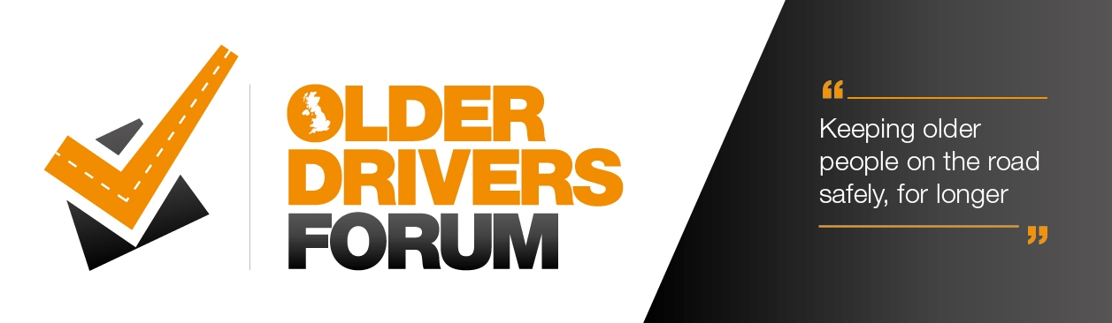
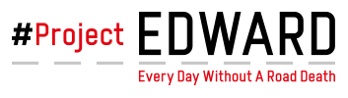
Older Drivers Forum webinars
Supporting Project Edward

The Older Drivers Forum are supporting Project Edwards week of action, themed ‘Fit for the Road’ between the 13th to 17th September 2021. The Forum will be running a series of six free webinars during the week. Each webinar is on a different subject and designed to help and support the mature motorist to carry on driving safely for longer.

Project EDWARD stands for 'Every Day Without A Road Death’ and is an annual UK-wide road safety campaign backed by government, the emergency services, highways agencies, road safety organisations and British businesses.

Shockingly, on average 5 people a day are killed and around 150,000 people are injured each year on roads in Great Britain. Unfortunately, 20% of all deaths on our roads are older people. As older licence holders are increasing every year, fatalities for drivers aged 70 and over are forecasted to increase by 22% by 2040.

We know that older motorists have a wealth of experience, confidence and tolerance. However, sight, hearing, reaction time and judgement of speed and distance may not be as sharp as it once was.

The Older Drivers Forum is about keeping mature motorists on the road safely for longer. Whether that’s helping giving practical and informative help and support to continue driving or pointing people in the right direction for an assessment to identify their driving needs – from wing mirror adapters to an elevated driving seat – the Forum’s here to help and signpost you to the people to help. The Forum is a not-for-profit organisation made up of experts in road safety – from representatives from the emergency services, to charities, local authorities and businesses specialising in keeping older people on the road.

The chair and founder of the Older Drivers Forum Rob Heard said “We are excited and proud to support Project Edwards quest to make the roads safer for all. We can all become complacent about our driving and often pick up bad habits, which if not addressed can increase our risk of an incident on the roads. This week of webinars will help give advice on a number of subjects from Confidence building appraisals, Safe driving tips, Electric vehicles and driving with various medical conditions. We have a special webinar on Thursday afternoon hosted by Valerie Singleton OBE on Dash cams, which is one not to miss. We have 1000 free places, so make sure you book early to reserve your place.
I am looking forward to welcoming you again to our webinars. We have had great feedback from previous ones we have run, one person who attended said ‘Extremely useful and informative. This is definitely one of the better webinars I’ve attended over the past few months, both in presentation and content.’

The webinars are FREE and have expert speakers as well as participants being able to ask questions. People will need to register their place for each webinar and this can be done by visiting https://olderdriversforum.com/webinars/ . We have increased the number of places available this time to 1000 free places, so should be able to accommodate anyone who wishes to register.

