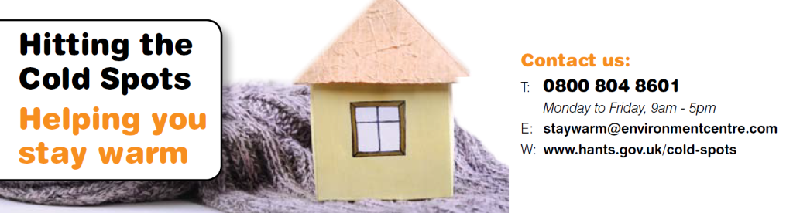
At Hitting the Cold Spots, we believe it’s vital that everyone can afford to stay warm and well in their homes.
This can be more difficult for those living in rural areas where homes are often older with poor insulation, reduced access to services, and off-gas fuel supplies. Staying warm and well can also be especially challenging for the elderly, and those with health conditions and/or disabilities.
Our trained Energy Advisors provide advice and support with:
- Broken heating
- Insulation
- Saving money on energy bills
- Funding for home improvements and energy discount opportunities
- Staying warm and well in your home
To prepare for the colder months, get in touch via:
- Freephone advice line: 0800 804 8601 (Monday - Friday, 9am - 5pm)
- Email: staywarm@environmentcentre.com
- Website: www.hants.gov.uk/socialcareandhealth/adultsocialcare/coldspots

